

**Progress Report of Final Year Project**

**AUTOMATIC CAR PARKING SYSTEM WITH SECURITY FEATURES**

**Submitted By**

Fatima Masood 21-UON-0917

Ansa Javed 21-UON-0912

**Supervisor**

Sir Zeeshan HOD Department of (CS)

**Submission Date**

16-December-2024

Contents

1. ABSTRACT 3

2. INTRODUCTION 3

3. PROBLEM STATEMENT 3

4. OBJECTIVES 3

5. PR0POSED SOLUTION 4

6. SYSTEM ARCHITECTURE 4

7. STEP-BY-STEP FLOW 4

8. SYSTEM DESIGN AND COMPONENTS 5

8.1 Hardware Components: 5

8.2 Software Components: 5

9. DEVICES USED 5

9.1 ARDUINO UNO 5

9.2 JUMPER WIRES 9

9.3 BREADBOARD 11

9.4 LCD DISPLAY WITH 12C MODULE 13

9.5 SERVOR MOTOR 15

9.6 IR SENSOR 17

9.7 ARDUCAM MINI NIGHT VISION 18

10. TECHNOLOGIES USED 20

11. METHODOLOGY 20

12. IMPLEMENTATION 20

13. IMPLEMENTATION PLAN 21

14. TESTING 21

15. SECURITY FEATURES 21

16. BENEFITS 21

17. TECHNICAL SPECIFICATIONS 21

18.Challenges Faced 22

19.FUTURE SCOPE 22

20. CONCLUSION 22

21.REFRENCES 22

## 1. ABSTRACT

This report outlines the development of an "Automatic Car Parking System with Security Features." The system aims to solve common parking problems like space mismanagement and security risks by combining advanced technologies such as IoT and sensors. The goal is to provide efficient, secure, and user-friendly parking experiences.

## 2. INTRODUCTION

Parking lots in cities often face problems like congestion, inefficient use of space, and lack of security. Manual systems are slow and prone to errors. This project provides a solution by automating parking with sensors and cameras.

Key Highlights of the Project:

* Automatic vehicle detection and entry.
* License plate recognition for security.
* Alert system for unauthorized vehicles.

## 3. PROBLEM STATEMENT

Conventional parking systems present several challenges

* Poor space utilization, leading to wasted capacity.
* Delays caused by manual management, especially during peak hours.
* Vulnerability to theft and damage due to limited security measures.

## 4. OBJECTIVES

* Create a parking system that optimizes space usage automatically.
* Enhance security with surveillance cameras and number plate recognition.
* Design a scalable solution that can adapt to different parking facilities.

## 5. PR0POSED SOLUTION

This project solves these problems with an automated parking system that:

* Detects vehicles using sensors.
* Reads license plates for vehicle identification.
* Opens the gate only for authorized vehicles.
* Alerts the system if an unauthorized car attempts entry.

## 6. SYSTEM ARCHITECTURE

VEHICLE ARRIVES

DETECTED BY SENSORS

CAMERA CAPTURES PLATE

SYSTEM PROCESSES PLATE

GATE OPENS OR ALARM TRIGGERS

## 7. STEP-BY-STEP FLOW

* Detect Vehicle.
* Capture license plate image.
* Compare plate with data base.
* If authorized than open gate.
* If not authorized than trigger alarm.

## 8. SYSTEM DESIGN AND COMPONENTS

### 8.1 Hardware Components:

* Sensors: Ultrasonic sensors for vehicle detection and RFID readers for user identification.
* Cameras: High-resolution cameras for monitoring and number plate recognition.
* Controllers: Raspberry Pi or Arduino boards for controlling system operations.
* Barriers: Automated gates for managing entry and exit.
* Displays: LED screens showing slot availability.

### 8.2 Software Components:

* Write Python code for plate recognition using OpenCV.
* Store and verify plate data in the database.

## 9. DEVICES USED

* Arduino UNO
* Jumper Wires
* Breadboard
* LCD Display with 12C Module
* Servo Motor
* IR Sensor
* Arducam Mini Night Vision

### 9.1 ARDUINO UNO

Arduino is an open-source electronics platform based on easy-to-use hardware and software. Arduino boards are able to read inputs - light on a sensor, a finger on a button, or a Twitter message - and turn it into an output - activating a motor, turning on an LED, publishing something online. Arduino UNO is a low-cost, flexible.

Arduino boards can work well using power from a USB port. The USB port provides 5V DC power, which is enough for the board. You can connect the USB cable to:

1. A computer (PC or laptop).

2. A wall socket adapter (like a phone charger).

3. A portable power bank (for mobility).

This makes Arduino easy to power without needing extra batteries or complex setups.

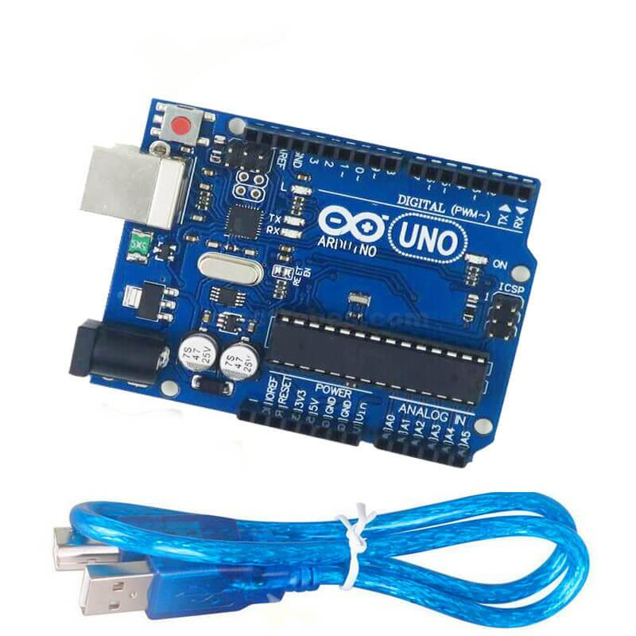

**Use of Arduino Uno in Automatic Car Parking System with Security Features**

Arduino Uno is the main control unit in an Automatic Car Parking System with Security Features. It processes input from sensors, controls hardware like gates and alarms, and ensures smooth and secure operation.

Here’s how Arduino Uno is used:

**1. Vehicle Detection**

**Sensors:**

Arduino Uno connects to IR or ultrasonic sensors to detect vehicles at the entry or exit.

**How It Works:**

When a car approaches, the sensor sends a signal to Arduino, which activates the system to process further steps.

**2. License Plate Detection (Camera Integration)**

**Camera Triggering:**

Arduino Uno can send a signal to a connected camera module to capture an image of the car’s number plate.

**How It Works:**

Once the vehicle is detected, Arduino triggers the camera and communicates with a computer or system for license plate verification.

**3. Gate Control**

**Controlling Motors:**

Arduino Uno connects to motor drivers or servo motors to open and close the parking gate.

**How It Works:**

After vehicle detection and license verification, Arduino sends a signal to the motor to lift the gate.

Once the vehicle enters or exits, it closes the gate.

**4. Security Features**

**Alarm System:**

If an unauthorized vehicle is detected, Arduino activates a buzzer or alarm for security.

It can also send a signal to alert security personnel.

**LED Indicators:**

Arduino controls LED lights to indicate the status (e.g., green for entry, red for restricted).

**5. Display System**

**LCD or LED Display:**

Arduino Uno can connect to a display to show parking status, such as:

"Parking Full"

"Gate Open"

"Unauthorized Vehicle"

**6. Data Logging (Optional)**

Arduino Uno can send data (e.g., time of entry/exit, vehicle details) to a connected computer or storage system for record-keeping.

**Why Use Arduino Uno?**

* Reliable Control: Manages sensors, motors, and alarms effectively.
* Simple Integration: Works easily with components like IR sensors, cameras, and displays.
* Affordable: Cost-effective for student projects.
* Expandable: Can add more features like Wi-Fi modules (ESP8266) for remote monitoring

### 9.2 JUMPER WIRES

Jumper wires are essential for connecting different components in an Automatic Car Parking System. They act as the communication bridge between sensors, the Arduino Uno, motors, and other hardware.

**How Jumper Wires are Used in the System**

**1. Connecting Sensors to Arduino Uno:**

Purpose: To connect IR or ultrasonic sensors to the Arduino for vehicle detection.

**Example:**

One wire connects the sensor's power pin (VCC) to the Arduino's 5V pin.

Another wire connects the ground pin (GND) to the Arduino's GND pin.

The signal pin of the sensor connects to any digital pin on the Arduino.

**2. Connecting Motors to Arduino:**

**Purpose:** To connect gate motors via a motor driver module (e.g., L298N).

**Example:**

Jumper wires link the motor driver’s input pins to Arduino’s digital pins to send motor control signals.

Power and ground are also connected using jumper wires.

**3. Integrating Buzzer and LEDs:**

**Purpose:** To connect LEDs or a buzzer for status indications or alarms.

**Example:**

A wire connects the LED or buzzer's positive pin to a digital pin on the Arduino.

Another wire connects the ground pin to Arduino’s GND pin.

**4. Connecting Display Module:**

**Purpose:** To link an LCD or LED display for showing parking status or warnings.

**Example:**

Data pins of the display are connected to Arduino’s digital pins using jumper wires.

Power and ground are similarly connected.

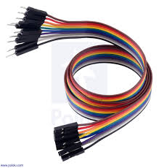

**Types of Jumper Wires Used**

* Male-to-Male Wires
* Male-to-Female Wires
* Female-to-Female Wires

**Why Jumper Wires Are Important?**

* Easy Connections: Simplify wiring and testing during prototyping.
* Reusable: Can be used multiple times for different setups.
* No Soldering Required: Makes the system neat and easy to modify.
* Affordable: Available at low cost

### 9.3 BREADBOARD

A breadboard is a rectangular plastic board with a bunch of tiny holes in it. These holes let you easily insert electronic components to prototype (meaning to build and test an early version of) an electronic circuit, like this one with a battery, switch, resistor, and an LED (light-emitting diode).

**Holes in breadboard**

Full-size breadboard . Total 830 holes . Standard 2.54mm (0.1") spacing between two holes .

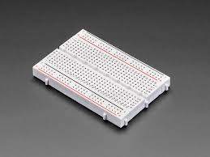

**How Breadboard is Used in the System**

**1. Connecting Components:**

Components like sensors, LEDs, resistors, and wires are plugged into the breadboard.

It provides a temporary platform to connect everything to the Arduino.

**2. Testing the Circuit:**

The breadboard allows you to test how sensors and other devices work together before finalizing the design.

If there’s an error, you can easily rearrange connections.

**3. Power Distribution:**

Breadboards have rows and columns for distributing power (5V) and ground (GND) to all connected components.

**4. Avoiding Soldering:**

No need to permanently connect wires or components. You can quickly make changes to improve the system. Example in the Parking System

**Example in the parking system**

* **Sensor Connection:**

Place IR or ultrasonic sensors on the breadboard, connect them to Arduino pins using jumper wires.

* **LED/Buzzer Connection:**

Add LEDs and a buzzer to the breadboard to test alarms or status indicators.

* **Motor Driver Connection:**

The motor driver module can also be connected to the breadboard to control gates.

**Advantages of Using a Breadboard**

* Easy to Use: No need for soldering, making it beginner-friendly.
* Flexible: Allows quick changes to the circuit design.
* Reusable: Can be used in future projects.
* Affordable: Costs less

### 9.4 LCD DISPLAY WITH 12C MODULE

An LCD display with an I2C module is used in the Automatic Car Parking System to show important information like parking status, alerts, or vehicle-related messages. The I2C module simplifies the connection, reducing the number of wires needed between the display and the Arduino Uno.

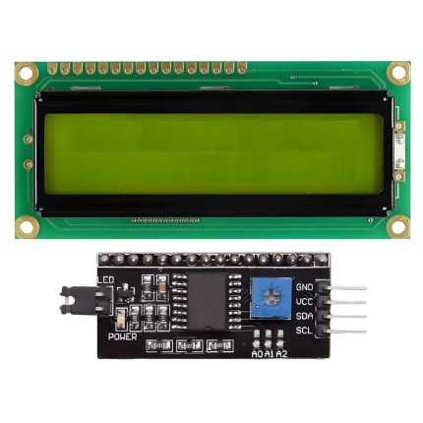

**How the LCD with I2C is Used**

**1. Display Parking Status:**

The LCD can show messages like:

"Parking Available"

"Parking Full"

"Unauthorized Vehicle Detected"

**2. Vehicle Detection Alerts:**

It displays the message when a vehicle is detected or allowed to enter/exit.

**3. User-Friendly Interface:**

Makes the system easier to understand for users and operators.

**4. Real-Time Updates:**

The Arduino sends live data to the LCD via the I2C module, keeping the display updated.

**Benefits of Using an I2C Module with the LCD**

**1. Simplified Wiring:**

Without I2C, LCDs require many wires for connection (6-8 pins).

With I2C, only 4 pins are needed:

VCC (Power)

GND (Ground)

SDA (Data)

SCL (Clock)

**2. Saves Arduino Pins:**

Arduino pins are freed up for other components, like sensors and motors.

**3. Easy to Program:**

I2C modules work with ready-made libraries in Arduino IDE (like LiquidCrystal_I2C).

**4. Clear Display:**

The 16x2 LCD (16 characters, 2 rows) or 20x4 LCD (20 characters, 4 rows) can display multiple messages clearly.

**Example Usage in the System**

* When a car approaches:

LCD Display: "Vehicle Detected, Opening Gate."

* If the parking is full:

LCD Display: "Parking Full, Please Wait."

* If an unauthorized vehicle tries to enter:

LCD Display: "Access Denied, Alert Sent."

**Advantages in Your Project**

* **Professional Look**: Makes the system user-friendly and professional.
* **Affordable:** I2C LCD modules cost around PKR300-500 ($4-7).
* **Compatible:** Easily works with Arduino Uno.

### 9.5 SERVOR MOTOR

A servo motor is used in the Automatic Car Parking System to control the movement of the gate. It opens and closes the gate when a car is detected and authorized to enter or exit.

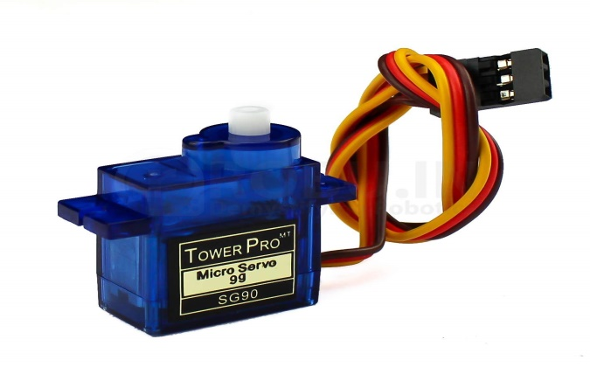

**How Servo Motor is Used**

**1. Gate Opening and Closing:**

When a car approaches, the servo motor rotates to open the gate.

After the car enters or exits, the motor rotates back to close the gate.

**2. Controlled Movement:**

The servo motor moves precisely to the required angle, ensuring smooth operation of the gate.

**3. Signal from Arduino:**

The Arduino sends a signal to the servo motor based on sensor input or license plate verification.

**Why Use a Servo Motor?**

**1. Precise Control:**

The servo motor moves to specific angles (e.g., 0° for closed, 90° for open), making it ideal for gates.

**2. Compact and Powerful:**

Despite its small size, it is strong enough to handle lightweight gates.

**3. Easy to Use:**

It connects directly to the Arduino with just three wires:

Power (VCC)

Ground (GND)

Control Signal

**4. Affordable:**

A servo motor costs around PKR200-400 ($3-6), making it budget-friendly for projects.

**Example Workflow**

* Step 1: A car is detected by the sensor.
* Step 2: Arduino checks if the car is authorized.
* Step 3: If authorized, Arduino sends a signal to the servo motor to rotate and open the gate.
* Step 4: Once the car enters or exits, the servo motor rotates back to close the gate.

### 9.6 IR SENSOR

An IR (Infrared) Sensor is used in the Automatic Car Parking System to detect vehicles. It works by using infrared light to sense when a car is nearby.

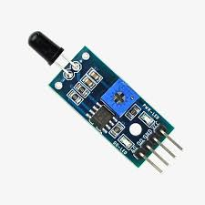

**How IR Sensor is Used**

**1. Vehicle Detection:**

The IR sensor detects when a car is at the entrance or exit.

It sends a signal to the Arduino to start the next step, like opening the gate.

**2. Gate Automation:**

The sensor ensures that the gate only opens when a vehicle is present.

**3. Counting Cars:**

IR sensors can count how many cars enter or leave the parking lot to manage space.

**Why Use an IR Sensor?**

* **Simple to Use:**

Easy to connect with Arduino and requires only 3 pins:

VCC (Power)

GND (Ground)

OUT (Signal)

* **Affordable:**

IR sensors are cheap and cost around ₹50-100 ($1-2).

* **Reliable:**

Works well for detecting vehicles without touching them.

**Example in the System**

* Step 1: A car approaches the gate.
* Step 2: The IR sensor detects the car and sends a signal to the Arduino.
* Step 3: The Arduino activates the servo motor to open the gate.

### 9.7 ARDUCAM MINI NIGHT VISION

The Arducam Mini Night Vision Camera is a small camera module that can capture clear images even in low light or at night. In the Automatic Car Parking System, it is used for detecting and reading vehicle license plates at all times, including in dim lighting.

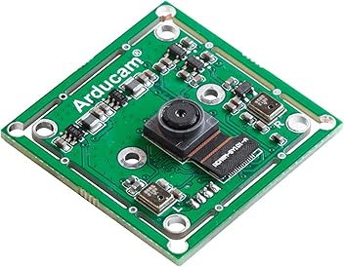

**How It Works in the System**

**1. License Plate Detection:**

The Arducam captures the image of the vehicle’s license plate when it enters or exits the parking area.

The image is sent to the system for verification or record-keeping.

**2. Night Vision Capability:**

It has built-in infrared (IR) LEDs or supports external IR lights, making it effective in low-light conditions.

**3. Integration with Arduino:**

The camera connects to the Arduino board, which triggers it to take pictures based on signals from sensors.

**Why Use Arducam Mini Night Vision Camera?**

**1. Clear Images in Low Light:**

Works well in parking lots with poor lighting or during nighttime.

**2. Compact and Lightweight:**

Easy to install in the parking system without taking much space.

**3. Compatible with Arduino:**

Can easily be connected to Arduino Uno or similar microcontrollers.

**4. Affordable:**

Costs around ₹1,500-2,500 ($20-30), making it a budget-friendly option for student projects.

**Example Workflow in the Parking System**

Step 1: A vehicle is detected by an IR sensor.

Step 2: The Arduino triggers the Arducam to capture an image of the license plate.

Step 3: The captured image is sent to a computer or processing system for verification.

Step 4: If the vehicle is authorized, the gate is opened.

## 10. TECHNOLOGIES USED

* **Programming Language:** Python (for processing images) and C++ (for hardware control).
* **Software Libraries:** Open CV for license plate recognition.
* **Database:** SQL for storing data of authorized vehicles.
* **Hardware:** Raspberry Pi, IR sensors, cameras, and motors.

## 11. METHODOLOGY

The project follows these key steps:

* **Research:** Analyzing existing systems and identifying improvement areas.
* **Design:** Developing system architecture and selecting the required components.
* **Development:** Writing software in Python and C++ and assembling hardware.
* **Testing:** Conducting functional and performance tests in a controlled environment.
* **Deployment:** Installing the system in a real-world setting and collecting user feedback.

## 12. IMPLEMENTATION

The project is implemented in the following steps

**1. Hardware Integration:**

* Connect sensors to detect vehicles.
* Mount cameras to capture license plate images.
* Install gate motors for automatic control.

**2. Software Development:**

* Write Python code for plate recognition using OpenCV.
* Store and verify plate data in the database.

## 13. IMPLEMENTATION PLAN

* Phase 1: Research user needs and system requirements.
* Phase 2: Design hardware and software architecture.
* Phase 3: Build and integrate system components.
* Phase 4: Test for functionality, reliability, and user-friendliness.
* Phase 5: Deploy the system and collect user feedback for further optimization.

## 14. TESTING

Test the system with authorized and unauthorized vehicles.

## 15. SECURITY FEATURES

* **License Plate Recognition:** Ensures that only authorized vehicles enter the parking lot.
* **Real-Time Alerts:** The system notifies the operator if an unauthorized vehicle is detected.
* **Data Logging:** Every entry and exit is recorded for audit purposes.

## 16. BENEFITS

* **Improved Efficiency:** Reduces time spent searching for parking spaces.
* **Enhanced Security:** Prevents unauthorized access and theft.
* **User Convenience:** Allows easy booking and navigation.
* **Scalability:** Adapts to parking facilities of all sizes.

## 17. TECHNICAL SPECIFICATIONS

* **Sensors:** Ultrasonic with ±1 cm accuracy.
* **Cameras:** Full HD with night vision capability.
* **Controller:** Raspberry Pi 4 with 4 GB RAM.
* **Software:** Programming languages: Python, C++. Database: MySQL for scalable data handling.
* **Power Supply:** Operates on 12V DC.

## 18.Challenges Faced

* + - **Lighting Conditions:** Low light affected camera performance, requiring additional software adjustments.
    - **Sensor Calibration:** Fine-tuning sensors for accurate vehicle detection.
    - **Processing Speed:** Optimizing response time for real-time operations.

## 19.FUTURE SCOPE

* Integrating mobile apps for real-time booking and payments.
* Supporting multi-story parking lots with advanced monitoring.

## 20. CONCLUSION

The "Automatic Car Parking System with Security Features" is a cutting-edge solution for modern parking challenges. It leverages advanced technologies to improve efficiency, security, and user satisfaction. By addressing common pain points, the system sets a benchmark for innovation in urban parking management. Its adaptability and ease of use make it a valuable addition to any facility.

## 21.REFRENCES

* [www.chatgpt.com](http://www.chatgpt.com)
* [www.youtube.com](http://www.youtube.com)
* [www.wikipedia.com](http://www.wikipedia.com)
* Past Research Papers

Kumar, S, AND Sharma ,R, “Smart Parking System Using IoT and Arduino”International Journal of engineering and Technology 2021.

* [www.arduino.cc](http://www.arduino.cc)
* Book

Massimo Banzi,Getting Started with Arduino,3rd Edition, Maker Media,2015.

* [www.sparkfun.com](http://www.sparkfun.com)